

PURLWELL INFANT & NURSERY SCHOOL

Purlwell Lane

Batley

WF17 7PE

PROSPECTUS

2026 – 2027

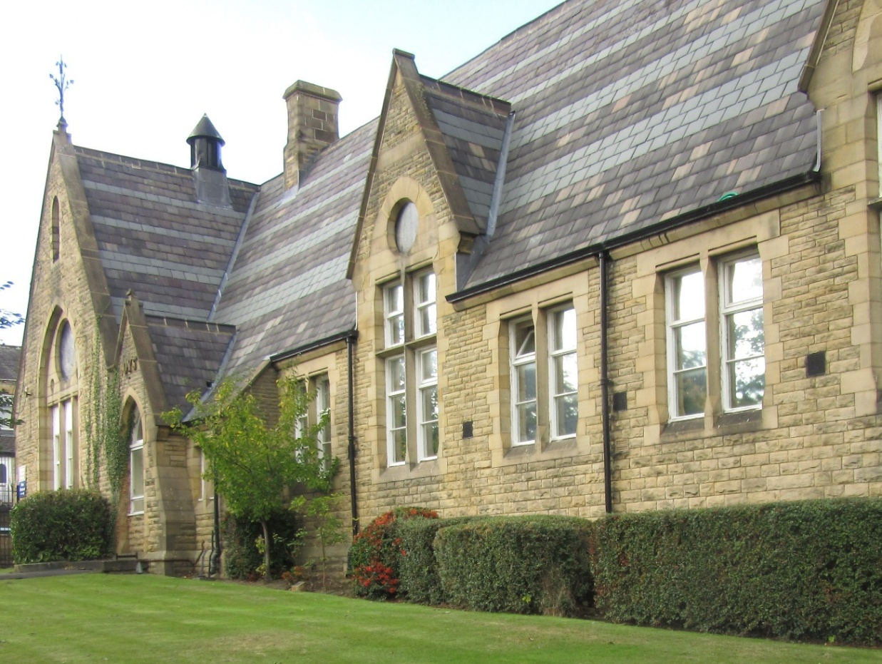

If you would like a copy of any of our school policies please ask at the office

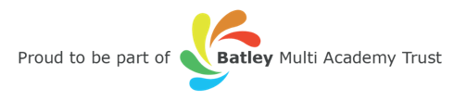

Welcome

Dear Parents and Carers

We are proud of our school and our learners.

Our school promotes positive relationships with all stakeholders to create a happy, secure, caring, positive and fun environment where all learners have the right to learn. Every child is treated as an individual and as an important member of the school community.

By nurturing positive working relationships with parents, carers and learners we believe that we provide learners with the best care, support, education and opportunities.

We look forward to working with you to help your child achieve to their full potential.

Yours sincerely

Mrs S Nazam
Headteacher



Collaborate |  | Aspire |  | Respect |  | Empathy

Learners are at the heart of every decision we make.

Introduction

The aim at Purlwell Infant and Nursery School is for all learners to be educated to a high standard and to reach their full potential in all aspects of school life.

By the time they leave Purlwell, the learners are expected to be independent, self-disciplined, to have an awareness of the world they live in and to possess high self-esteem.

Our school is a Victorian building built in the 1800s and extended in 1983. There are at present nine teaching areas plus a hall, a Headteacher’s office, admin office, a staffroom, library, intervention suite, administration meeting room, resource room and School Business Managers office. There is also a large nursery and a separate pre-nursery. To the exterior there is a large tarmac playground with climbing frame, trim trail and a separate Foundation Stage playground.

Visits to school

We encourage prospective parents to visit our school. If you would like to come and have a look at what we get up to at Purlwell Infant and Nursery School, please phone the school office to make an appointment.

Tel: 01924 326734

There is a range of information on the school website.

Ofsted report

Here are some of the quotes from our last Ofsted report in March 2022:

- This school continues to be good.
- This is a school at the heart of the community
- Positive and caring relationships between all adults and pupils are a key feature of Purlwell Infant and Nursery School.
- Pupils demonstrate excellent learning behaviours.
- Pupils feel safe and know that they can speak to any adult in school if they are worried. There have been no reported incidents of bullying.
- Parents welcome the extraordinary lengths that staff go to, to care for their children.
- Leaders have established an ambitious and well-sequenced curriculum.
- The early years curriculum is carefully designed to ensure that it introduces the core knowledge and skills that children will need to be successful in key stage 1.
- A mastery approach to mathematics is well established in all year groups.
- Teachers ensure that pupils develop a strong understanding of positive friendships and relationships
- A broad range of trips and visitors help to widen pupils’ learning experiences.
- All staff speak positively about the strong team ethos across the school.
- Governors have an informed understanding of school developments.
- Leaders ensure that staff have the training they need to keep pupils safe

School Contact Details

School Address: Purlwell Infant & Nursery School
Purlwell Lane
Batley
West Yorkshire
WF17 7PE

Telephone No: 01924 326734
E-Mail Address: office@purlwellschool.co.uk
Website: www.purlwell.org
Instagram: purlwell_eyfs

School office is open: 8.30am to 3.30pm (answering machine available 24 hours)

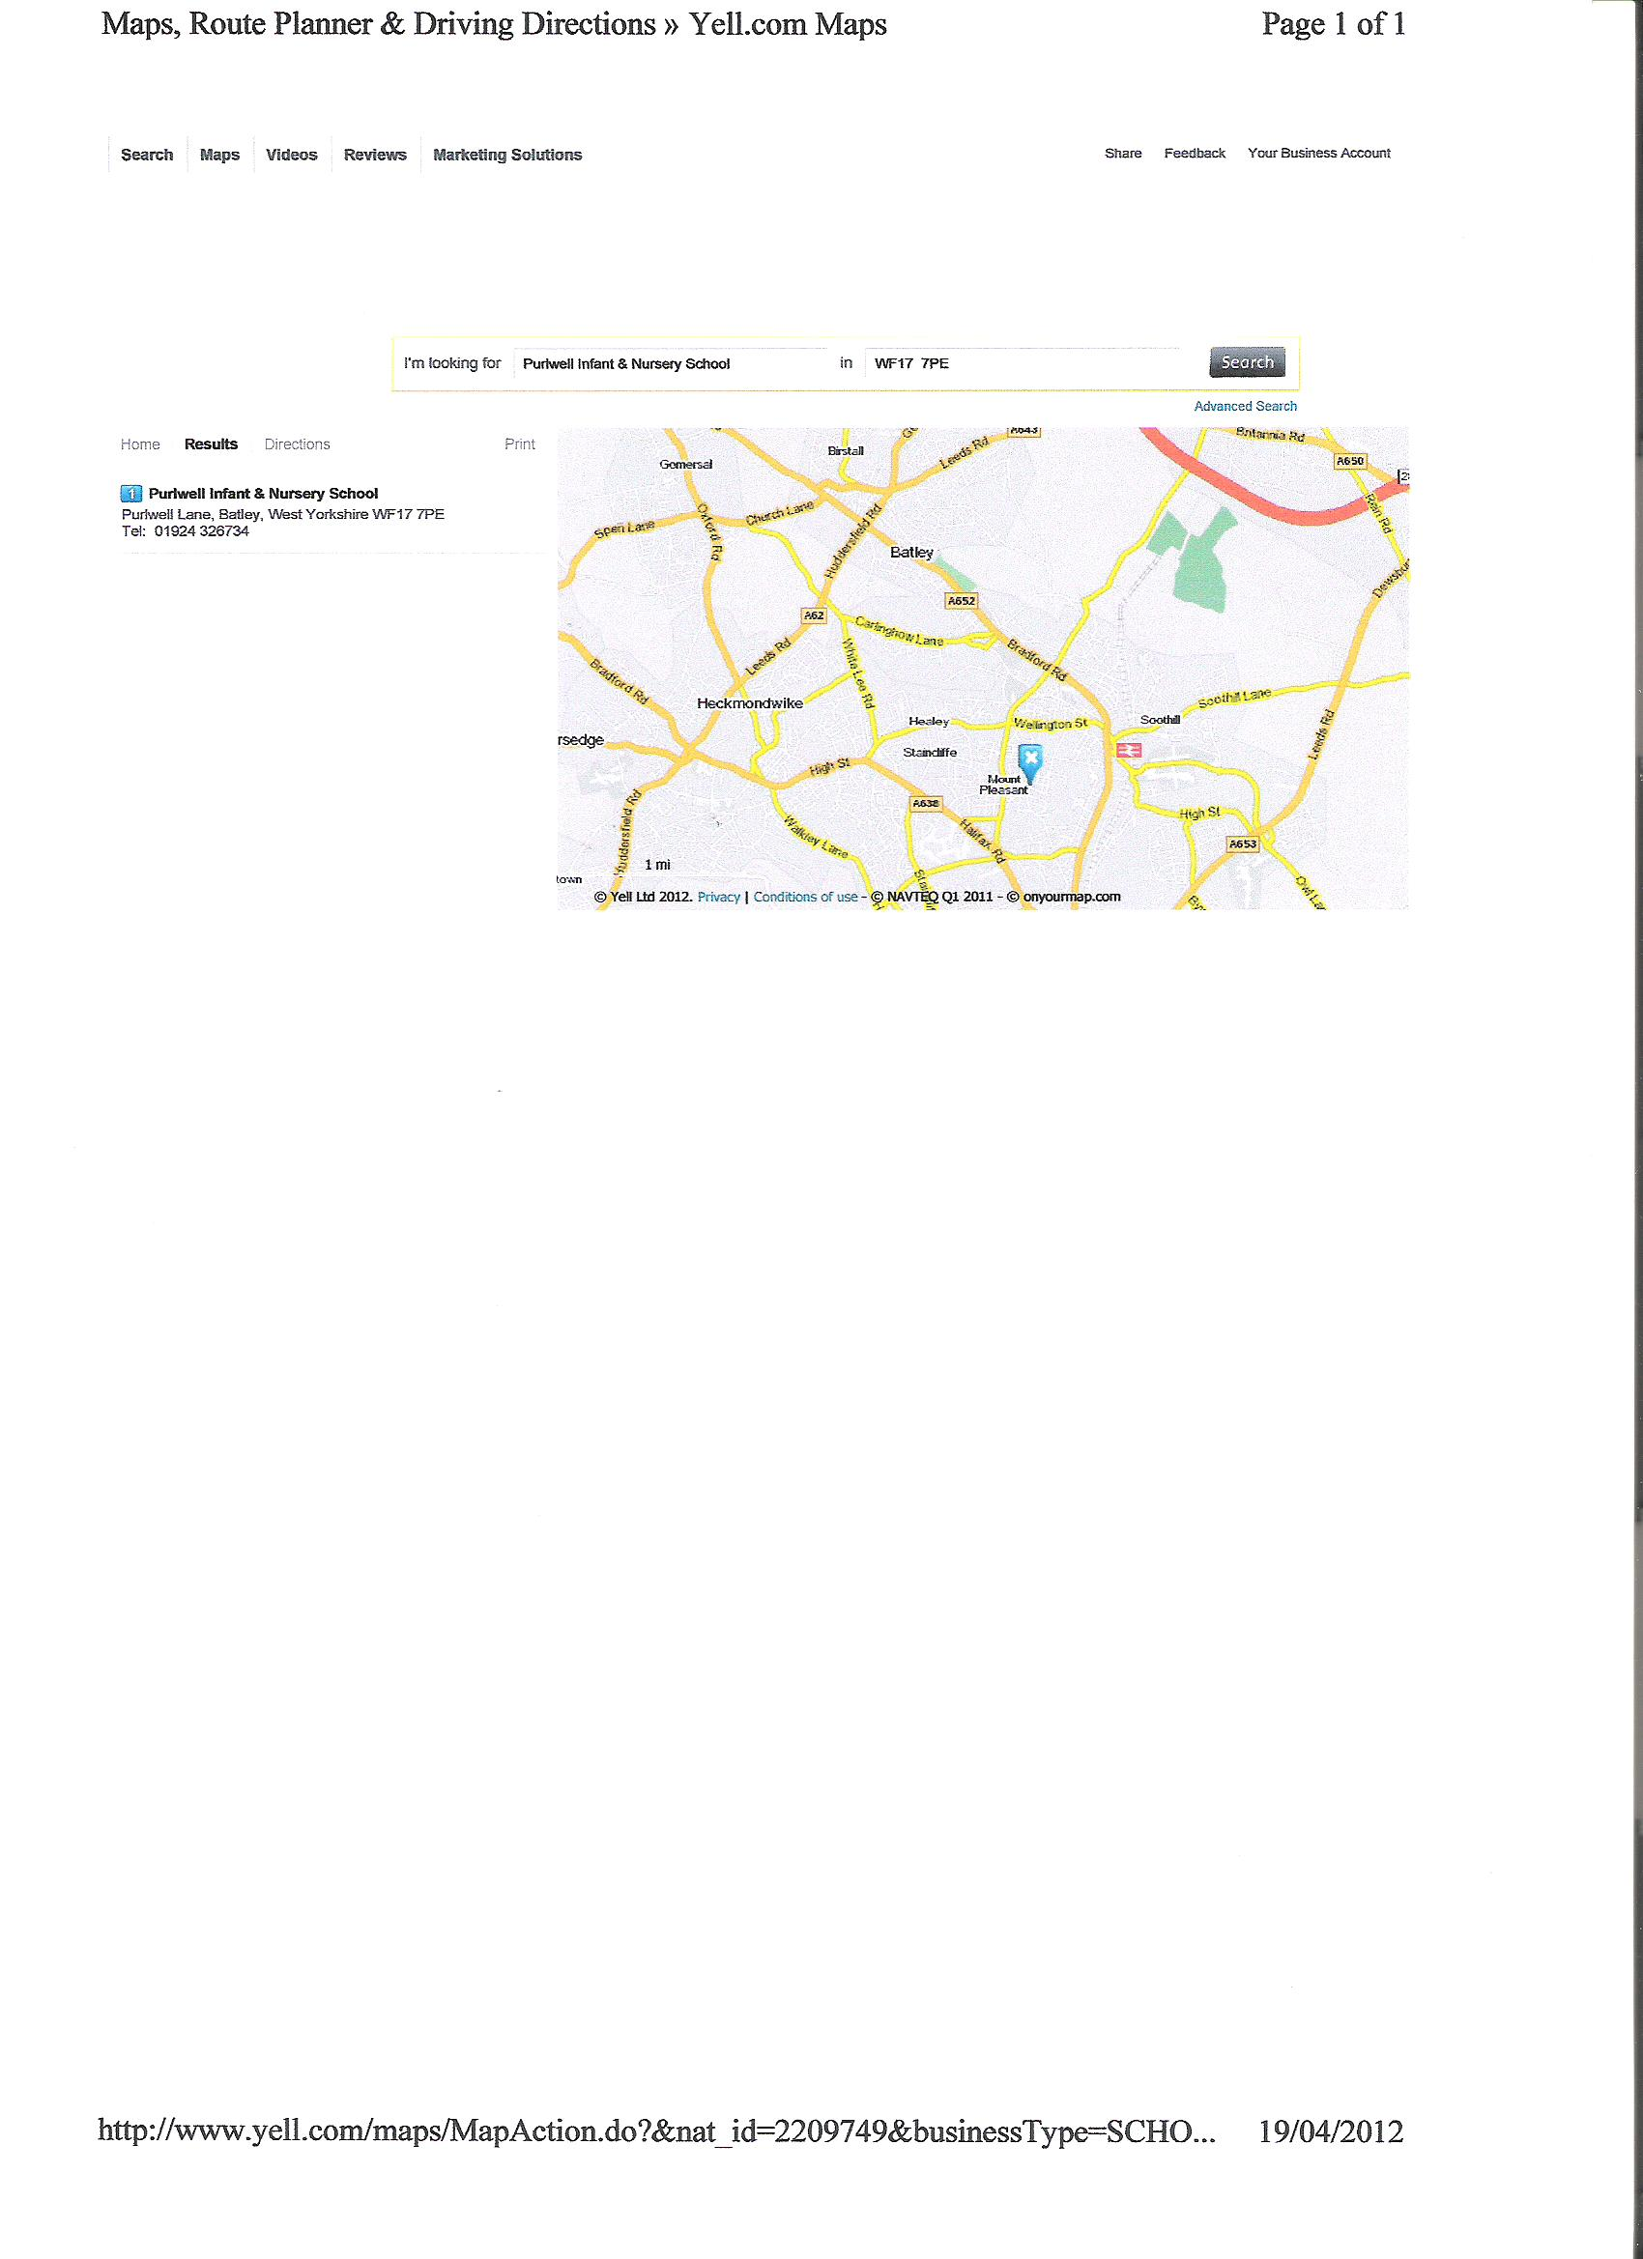

Vision, motto, ethos and values:

Purlwell staff will work together and with others (parents and experts) to build firm foundations so learners are ready for every stage and phase of their learning. Aspirational targets will be set and regularly reviewed so every learner reaches their full potential. We want our learners to:
- be successful life-long learners who are confident, articulate and respectful of others
- have the skills to deal with and overcome all the challenges they will encounter in life
- be prepared to become proactive citizens who contribute positively to their communities and society

We aim to achieve this by:
- Instilling curiosity, confidence, resilience and independence
- Increasing communication, knowledge and skills
- Improving personal, social and emotional literacy

We will achieve this by:
- Creating a caring, stimulating and organised environment where learners feel safe, secure, happy and confident.
- Providing a range of opportunities to broaden and build on learners experiences throughout their time at Purlwell.
- Sequencing and building on experiences and learning so learners can do more, know more
and remember more, year on year.
- Having clarity and a clear rationale for what is being taught when and why.
We will do this through:
- Having thorough knowledge of learners starting points and their previous experiences
- Teaching a broad, balanced, relevant and differentiated curriculum that meets the needs of all pupils equally, including those with special educational needs.
- Whole school events, assemblies and charitable giving opportunities
- Providing opportunities for parental involvement and learning

Curiosity, confidence, resilience and independence will be developed through:
- Careful planning and use of appropriate resources
- Visits out of school and visitors in school
- Exposure to new and different experiences
- Using a range of teaching activities to ensure all succeed
- Opportunities to become independent learners through the Steps to Success and the development of metacognitive skills

Increasing communication, knowledge and skills will be developed through:
- A focus on developing tier two and tier three vocabulary
- Opportunities to revisit learning and applying this across the curriculum
- Good modelling from all adults
- Opportunities to get involved in extra curricula activities
- Harvest Assembly, Nativity, Ramadan Assembly
- Class Assembly performances

Personal, social and emotional literacy will be developed through:
- Providing a caring and nurturing environment
- Understanding self and others / restorative practice
- Peer and group learning opportunities
- Steps to success
- Involvement in working with others in different contexts through planned activities and community projects

Our aims will be achieved through relevant targets on the School Development Plan, Action Plans and in policies and procedures that underpin good practice.

OUR CURRICULUM OFFER

By the end of their time at our school
Our learners will have;
- Achieved to their full potential
- Achieved age expected standards or above in reading, writing and maths
- Achieved the key skills of teamwork, independence and cooperation.
Our learners will have participated in;
- A broad and balanced curriculum
- Activities to develop an understanding of diversity and respect
- Charitable giving
- Participated in a live performance
- Outdoor activities
- Offsite visits to enrich core learning
- Enterprise activities
- Community activities
- An environmental project
- After school clubs
- Cooking
- A democratic process
- Representing their school
- Road safety lessons
- A mosque and church visit
- A weekly time of reflection
- Opportunities to take responsibilities
- Playing a musical instrument

Everyone will have experienced;
- A feeling of being included
- Being listened to
- Being encouraged
- Being challenged
- Being prepared for their next step in education
- Being respected
A safe environment, knowing how to ask for help.
School Organisation

Learners spend 4 years at Purlwell School from Nursery through to Year 2 and each year group is classified as follows:

- 3 – 4 years old Early Years Foundation Stage - Nursery
- 4 – 5 years old Early Years Foundation Stage - Reception
- 5 – 6 years old Key Stage 1 - Year 1
- 6 – 7 years old Key Stage 1 - Year 2

The number of learners on roll and the number in each year group govern the arrangement of the classes. This often changes from year to year. Within each class, learners are taught individually, in groups and as a whole class according to their learning needs and ability.

Reception and Nursery learners follow the Early Years Foundation Stage curriculum. Learners in Years 1 and 2 study the National Curriculum. This underpins all future learning by supporting, fostering and promoting learners’ development.

Communication with Families

The school uses every opportunity to communicate effectively with all community members. This is achieved by using a range of strategies including:

- Letters home (read to all pupils in advance where appropriate)
- Email (we are using this mode of communication most)
- Newsletters
- Notice Boards
- School website
- Parents’ evenings
- Reports
- Text messaging
- Instagram

Parents are encouraged to communicate with school and their support and opinions are valued.

Working with Families

We encourage parents and family members to come into school and to be fully involved in their children’s education. If necessary, appointments can be made with your child’s class teacher or the Headteacher to discuss issues relating to your child. Bi-lingual support is available if required.

Parent’s evenings are held twice a year, when teachers report on learner’s progress and set targets for future progress. In addition, written reports are also provided at the end of each academic year.

During the year a number of other events, workshops, stronger together parent forums and meetings are held to which we invite parents to. We hope you will try to attend these events as they are invaluable in supporting your child’s education.

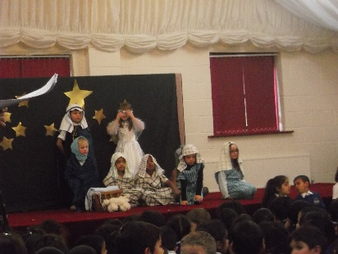
Events during the year include:

- Parents’ welcome meetings
- Curriculum meetings
- Class assemblies
- Winter and Summer Fairs
- Fundraising Events
- Festival day
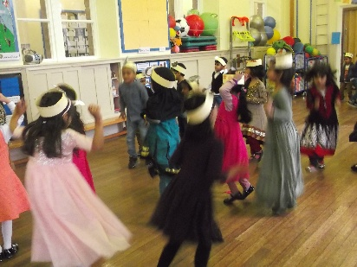
- Open mornings
- Sports day
- Inter school sports events
- Parents evenings
- Nativity performance
- Ramadan performance
- Parent workshops

Pre-School Education at Purlwell:

Stay and Play

Ready Steady Group

At Purlwell we recognise that the child’s first educator is the parent, therefore it is essential that we all work together to develop a partnership between home and school at the earliest opportunity.

Stay and Play sessions are run by our experienced Nursery Nurse on a weekly basis.

The term before learners start nursery, parents and learners are invited to attend Ready Steady group sessions, these help support a smooth transition. Purlwell staff run the sessions and all parents and learners are encouraged to attend. Please speak to the school office for further information.

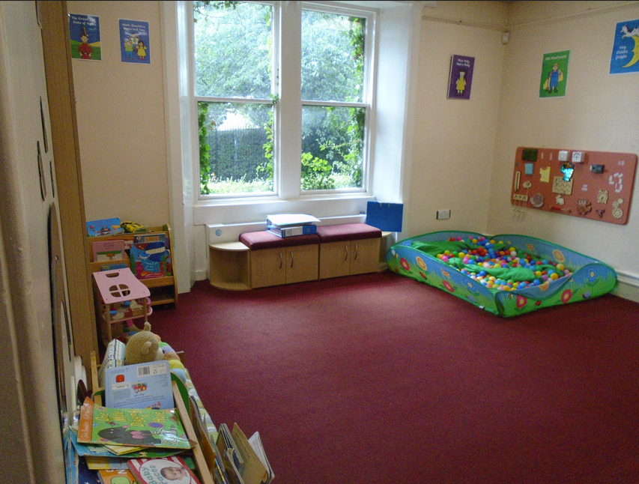

School council

We fully recognise the importance of pupil voice and involving the people who really count, in the development of the school. The learners in each class elect their own school council members. The elections are held every September to allow all pupils the chance to stand.

The school council meets to discuss school improvement. Learners’ opinions are sought on a wide range of issues and taken on board. There is a display board where members and notices are displayed.

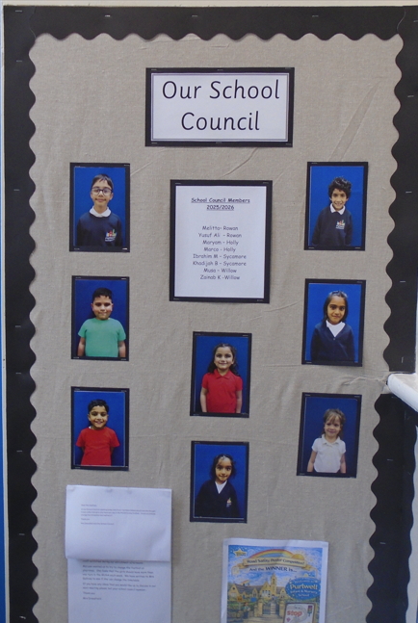

Admissions Procedures

The school is an academy school catering for learners in the age range 3 to 7 years.

Prospective parents are invited to visit the school at any time with or without their child by prior arrangement with the Headteacher.

Purlwell Infant and Nursery school has a one hundred and four place Nursery offering part-time places for pupils, in the term after their third birthday. Parents are advised to put your child’s name on the waiting list at the earliest opportunity.

Batley Multi-Academy Trust controls the admissions policy for pupils which can be found on our school website.
https://www.purlwell.org/Policies/

Nursery

Learners will start their Nursery education in the term after their third birthday, on a part time basis. We can accommodate both the universal entitlement (15 hours) and the extended entitlement (30 hours - subject to eligibility and availability).

Nursery session is:

Morning 8.30am to 11.30am
Afternoon 12:30pm to 3:30pm (only when available)

Currently we only have morning Nursery available but hope to have our 30-hour provision running soon for those who are eligible. For more information please contact the school office.

In Nursery, learners will learn through a variety of experiences and planned activities following the Early Years Foundations Stage Curriculum. These educational experiences provide learners with the foundations to build on in their later education. It is therefore a vital time in your child’s school life and regular attendance in Nursery is an expectation.

Since September 2017 our Nursery learners have started wearing a uniform. Parents have welcomed this and commented that it has greatly reduced issues relating to what to wear

Full Time education

Learners start their full-time education in Reception class in the September prior to their fifth birthday. During their Reception year learners are taught according to the EYFS Curriculum.

The staffing ratio in school is good. Every class has an educational support assistant working alongside the class teacher. In addition, support is put in place where there is the need. Your child will have the best opportunity to develop their skills in the English language and therefore fulfil their entitlement to be taught all areas of the EYFS.

Attendance
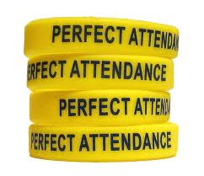
It is essential that your child comes to school every day unless they are ill. As required by law, we keep records of all learners absence; therefore we ask that parents inform the school as to why their child has been absent.

If your child is absent for any reason please telephone or email the school as early as possible. If you do not inform us of why your child is absent, it is our priority to contact you on the learners first day of absence.

Tel: 01924 326734
Email: office@purwellschool.co.uk

At Purlwell Infant & Nursery School the staff and Governors believe that:

Regular attendance and punctuality are essential

At Purlwell we ask all learners to have an attendance of 98% or higher across the academic year. These are high expectations of all our children, and that is why they go on to achieve so well. Children can only make good progress academically when they have high attendance. Every Day Counts.

High Attendance = High Achievement

Early Years and Key stage one are very important stages of education where foundations are laid for the future. Time missed in school is time lost in learning.

As parents, you are aware that you have a legal duty to send your child to school regularly. The Local Authority (LA) has the power to prosecute parents under the 1996 education act, section 444.

‘Any person found guilty of an offence against section 444 of the 1996 education act shall be liable for a fine not exceeding £1000’

At Purlwell attendance is closely monitored by our Attendance Officer. Contact is made with parents if attendance is falling, not where it should be or patterns of absence are emerging. Every effort is made to support good attendance. Letters are sent from the Headteacher if any child’s attendance is below 90%. We follow the Trust Attendance Policy which is on the school website.

Examples of Authorised Absence

- Illness
- Religious observance
- Family circumstances (ONLY after consultation with the Headteacher)

Examples of Unauthorised Absence

- Routine dental/medical appointments
- Shopping (for school or otherwise)
- Sleeping in
- Visiting relatives, or trips to the airport
- Any absence that has not been given a reason either by phone or letter by an adult
- Absence because of a parent or sibling’s illness / appointment

What parents should do

- Telephone school as early as possible on the first day of absence
- Make sure your child comes to school every day
- Tell your child how important it is to come to school
- Make routine dental, doctor or optician appointments out of the school day, or return as soon as possible after an appointment
What school will do

- Reward your child for good attendance
- Help in any way we can
- Refer to the school nurse
- Refer any persistent problems to the Attendance and Pupil Support Officer.

School day

It is very important to bring your child to school on time. We aim that the school day starts on time every day and punctuality is a good discipline for all learners to learn.

Reception Year 1 & Year 2

Morning - 8.45am – 11.35am Morning - 8.45am – 11.55am

Afternoon – 12.35pm - 3.20pm Afternoon – 12.55pm - 3.20pm

Morning registration will take place promptly at 8.55am.

We ask that learners are brought to school in the morning and collected every day by an adult. For their own safety. learners will not be allowed to be taken home by anyone under the age of fourteen.

In the morning the school doors are opened and manned by members of staff from 8.45am who will welcome the learners into school.

At the end of the day, your child will be dismissed from the same door they entered. It is important that you collect your child on time, as learners may become distressed if you are late.

Term time holidays

Parents should avoid taking their children out of school during term time for family holidays. Such absence can be very disruptive to pupils’ learning and development. Kirklees LA and the school has a comprehensive absence policy.

You must make an appointment to see the Headteacher if you intend to take your child out of school in term time.

Attendance

Attendance Figures | 2024-2025 | 2025 - 2026
Overall Attendance: | 94.57%  (96% excluding Eid) | 95.5%  (calculated on 25/06/26)

Trust Attendance Target: 98%

Emergency School Closure

Unfortunately, there are some exceptional times when the school may need to be closed for safety reasons. This would be due to weather conditions or a problem with gas, electric or water. In such cases we would try to give parents as much notice as possible prior to a closure.

- During severe weather listen to local radio stations and check the school website for updates.

- Texts will be sent to you if you have given the school an up to date mobile number (please note this can only be sent to one mobile number per family).

- If there is a problem during the day we will ensure your child is safe until you are able to collect them.

- The school has procedures for dealing with evacuation and alternative provision is available if necessary.

Medicine in School


Learners can only work well if they are fit and healthy. Please do not send your child to school if they are unwell. However, there may be times when your child is fit enough to be in school while finishing a course of medicine.

All medicines should be taken to the school office with clear instructions about the administration. You will be asked to sign a form giving permission for a member of staff to administer the necessary dose.

Usually only medicines prescribed by a doctor will be administered in school. All cases are considered individually.

We also need to know about any underlying medical conditions so that we can make provision for your child.

School Uniform

Our school encourages the wearing of a school uniform with the school logo on, but this is not compulsory. We can support with providing a uniform, enquire at the school office.

Sweatshirts, cardigans and waterproof coats with the school logo on are available from Smart Uniforms, 1-3 Cheapside, Bradford Road, Batley, WF17 5ND. Next to the Mill Village.

White shirt or white polo shirt |  | 
Grey trousers/ grey skirt or grey pinafore dress | 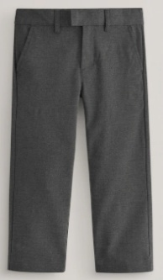 | 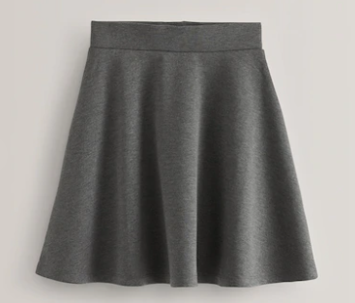 | 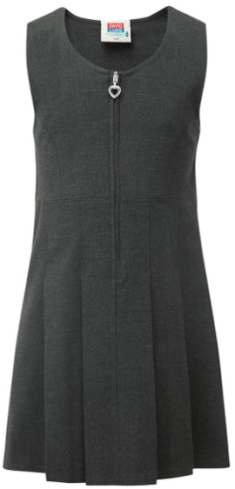
Navy blue jumper or cardigan |  | 
Summer Uniform  Blue and white checked gingham dress (can be work with white or blue leggings | 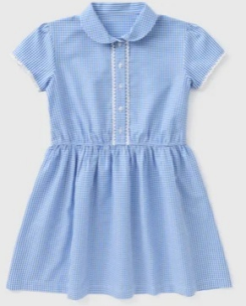 | Grey shorts  






Black shoes or completely black trainers. Sensible footwear – no open toe sandals. Hair accessories should be kept small and only blue or white

PE Kit

In the interest of health, safety and comfort, learners require comfortable clothes for PE, which should include:

Black jogging bottoms/ black leggings | 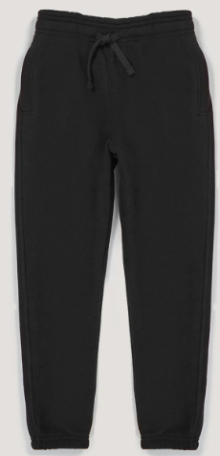 | 
PE Plain, coloured T-Shirt |  |  |  | 

- Pumps or trainers.

Learners will come to school wearing their PE kit on PE days. They must wear their school cardigan/jumper on top.


Jewellery or taweez cannot be worn during PE. Please remove these on PE days.

Please Note - If Earrings are not removed on PE days you will be called to come to school and remove them.

Lunch Time arrangements



School Dinners

The school runs a successful meals service, the meals served are nutritious and fresh produce is used. Any meat served is Halal and is sourced from a HMC approved abattoir. Menus are on display next to the hall, in reception and on the school website. Lunchtime supervisors will ensure that all learners are eating.

All learners up to and including year 2 are entitled to a school meal at no cost and we would encourage all learners to take up this opportunity.

If your child has specific needs, please inform the school so this can be discussed further.


Snacks

Learners are offered a piece of fresh fruit or vegetable every day. Learners are not allowed to bring sweets, crisps or chocolate at any time and chewing gum is banned from the premises.

DO NOT BRING NUTS INTO SCHOOL

Milk

Milk in the Nursery is free for all learners. For full time pupils, from the age of 5, milk is charged termly and the local authority subsidises this. You may be eligible for free milk, please enquire at the office. This is payable at the end of the term and orders cannot be changed once the term has begun. All learners are encouraged to drink milk unless they have an intolerance or allergy to it.

Lost Property

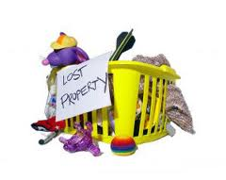
Naming all items of clothing reduces the risk of losing things. Please name items of learners clothing. We do keep lost property for a reasonable period of time, but it is often difficult to identify items that are not labelled. If your child has lost something please check in their classroom first and then in the lost property box.

First Aid

The school ensures that we have staff that are trained in administering first aid. Simple first aid is given at school when necessary. If an accident needs further medical attention we will make every effort to contact you first.

PLEASE ENSURE YOUR CONTACT DETAILS ARE UP TO DATE!

We have approximately 16 first aiders in school.

Water policy


We understand the need for learners to drink water regularly throughout the day. Drinking water is available in every classroom and we also ask that all learners bring to school a clear plastic bottle to school, filled with water (no juice or pop only water) and clearly labelled with your child’s name.

Informal/Formal concerns and complaints

Any concerns and complaints about school matters should be first brought to the attention of the relevant staff. Every effort will be made to address and resolve any concerns as soon as possible. The school follows the Trust Complaints Procedure and this can be accessed on the school website.

Our School Curriculum

The school has a statutory responsibility to follow the Early Years Foundation Stage Curriculum in Nursery and Reception class and the National curriculum in Key Stage One.
In Years 1 and 2 (Key Stage One) of your child’s education, lessons are taught in accordance with the National Curriculum. Literacy and Numeracy lessons take place every day in Key Stage one and teaching is approached through cross curricular themes.

At Purlwell we teach RE (Religious Education) following the Kirklees Education Authority’s agreed syllabus. The school is not affiliated to any particular religious denomination.

The school ensures that we follow the Government’s recommendation that all pupils will have two hours of Physical education (PE) per week. This involves using large and small apparatus indoors and outdoors, gymnastics and games. An interest in general team sports is encouraged and external coaches are sometimes used. All year groups have an annual sports day.

Each year group sends out a newsletter with curriculum information sheet each half term. This tells parents what their child will be working on for the coming weeks and how they can support them with language, vocabulary and homework.

Homework and reading books

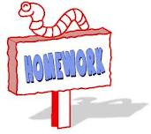
Every child at our school is encouraged to bring home reading books and read to their parents at home. Book bags can be purchased from the school office.

Parents are asked to ensure learners take care of the books at home. A charge of £5.00 is made if a book is damaged, defaced or lost.

Activities are set for learners to complete at home, you will be informed about class arrangements for returning work. This will be an extension of what has been taught in the classroom and learners may be directed to complete some activities online. Please help your child with their homework but do not do it for them or let older siblings do it!!

This is a good opportunity for parents to talk to learners about what they have been learning at school.



Assessments

We are very proud of the individual achievements and progress the learners at our school make. Data shows that our learners make good progress from their starting points into Nursery. Learners progress and attainment are measured using the following procedures:

- Teacher assessments of learners work are made continually throughout the year by every teacher.

- Statutory baseline assessments at the beginning of the Reception Year (from September 2021)

- Statutory Phonics test at the end of Year 1.

- Optional standardised tasks or tests are undertaken by all learners at the end of Key Stage one / Year 2. These are referred to as SATS or Standardised Attainment Tests.

We analyse our results and then support learners accordingly. Parents, the local authority and your child’s next school are informed of your child’s attainment level

Special Educational Needs

At Purlwell we will admit all eligible learners, regardless of their needs, provided we feel we can support their needs. We work closely with parents to ensure any transition runs as smoothly as possible.

Most learners require extra support from time to time. If we think this is the case for your child we will discuss our concerns with you and recommend some form of support. Likewise, if you have any concerns about your child, please do not hesitate to contact us.

Sometimes after working with you to support your child, we may decide to seek advice from an agency outside of school. With your permission, this advice may lead to your child receiving extra support from a specialist coming into school to work with your child for a short period of time. It is possible that after seeking advice from specialists a formal Education, Health Care Plan may be sought to enable your child to receive more long-term support. Some examples of short and long-term support available include:

- Support with learning difficulties
- Speech and Language therapy
- Support for visual difficulties
- Support for hearing difficulties
- Support for emotional or behavioural difficulties
- Physiotherapy.

A copy of the schools’ Special Educational Needs Policy is available on request and on the school website.

Accessibility

The arrangements for the admission of pupils with disabilities are in line with the LA’s policy and seek to ensure that the needs of all pupils are recognised and the placement is appropriate to their needs. The school’s Inclusion Policy ensures that there is no discrimination either direct or indirect against disabled pupils.

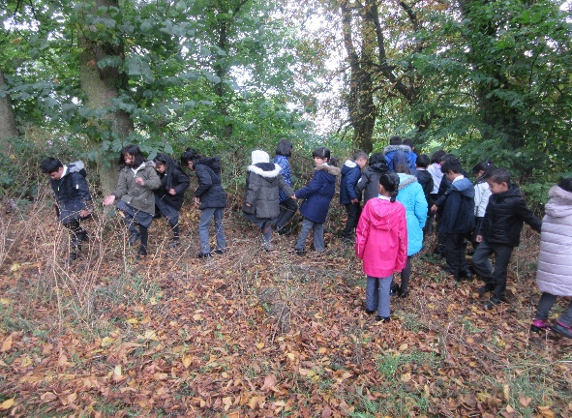
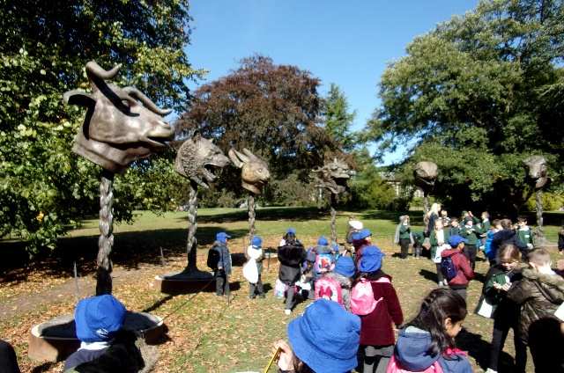

Safeguarding

“Safeguarding is everyone’s business – so never ever do nothing”

(A combination of two quotes by Lord Laming following the death of Victoria Climbie)

Designated Safeguarding Leads (DSL):
Mrs S Gallivan – Head of School - (Sept 2026 to Sept 2027)
Mrs Amy Boynton – Assistant Head - (Sept 2026 to Sept 2027)

Deputy DSL: Mrs J Shires
Mrs J Hamilton

Link Governors: Mrs S Palmer

Purlwell Infant and Nursery School is committed to ensuring the welfare and safety of all learners in school. All Kirklees schools, including ours, follow the Kirklees Safeguarding Children Board Procedures. The school will, in most cases, endeavour to discuss all concerns about learners with their parents. However, there may be exceptional circumstances when the school will discuss concerns with the Duty and Advice Social Care team and / or the police without parental knowledge (in accordance with Kirklees Safeguarding Children Procedures). The school will of course, always aim to maintain a positive relationship with parents. The school follows the Trust Safeguarding and Child Protection Policy, this is available on the school website.

Safer recruitment – All staff appointed to Purlwell Infant and Nursery school are subject to an enhanced Criminal Records Bureau (CRB) check or Disclosure Barring Service check.

Safeguarding – All staff are trained in Safeguarding procedures: The training includes understanding what is meant by physical, emotional, sexual abuse and neglect and how to recognise signs of these. Staff have also been trained in what to do if they suspect abuse, or if the abuse is disclosed to them. All disclosures or suspicions of abuse may be reported to the Designated Safeguarding Lead or directly to Kirklees Safeguarding and Assessment Service. In the absence of the Designated Safeguarding Lead reports are made to the Deputy Designated Safeguarding Lead. All referrals are dealt with following the Kirklees Safeguarding Children Board procedures. The Designated Lead Teachers for Safeguarding throughout 2026-2027 are Mrs Gallivan and Mrs Boynton.

Online safety

Every school has the responsibility of teaching learners on how to keep safe when using the Internet. The Internet is such a valuable resource but poses so many threats to the safety and wellbeing of the person using it. Learners are taught in school how to stay safe on the Internet and leaflets giving advice to parents are available.

If you have any concerns regarding Safeguarding issues please contact the Head of School.

A copy of the safeguarding policy is available on request and on the school website.

School Governors

The school’s Governing Body is involved in all aspects of school life. They act as a corporate body and support the school’s ethos. They are responsible for the strategic overview of the school through staff recruitment, agreeing policies and priorities and monitoring and reviewing whole school targets.

When a vacancy for a Parent Governor arises, all parents with a child in the school are notified.

Governing Body

Mrs S Palmer – Chair of Governors
Mrs T Rafique
Dr F McGregor
Mr A Patel
Mrs A Khan

School organisation 2026-2027

Teaching Staff
Mrs S Gallivan Head of School/SENCO/DSL
Mrs A Boynton Assistant Head/DSL (support SENDCO)

Ms N Afsha
Mrs A Hadaway
Miss L Hinchliffe
Miss J Horner
Mr J Field
Mrs K Patel

Teaching Assistants
Mrs C McGowan (Nursery Nurse) Mrs S Bhula
Mrs N Daji Mrs J Shires (HLTA) – Deputy DSL
Mr N Siddique Mrs F Daji
Mrs C Rutledge Mrs A Mamaniat
Mrs J Hamilton - Deputy DSL Mrs S Seedat
Mrs A Chopdat Mrs M Yasir

HLTA = Higher Level Teaching Assistant

Office Staff
Mrs L Walker – Senior Business Support Officer
Ms S Munir – Business Support Officer

Premises

Mr H Bham – Caretaker

End of Key Stage 1 Teacher Assessments over 3 year period

Curriculum are | 2023  School | 2023  National | 2024  School | 2024  National | 2025  School | 2025  National | 2026 School provisional
Reading
At least age expected | 75.4 | 68.3 | 73.2 | 71.4 | 70 | 71.5 | 72.5
Above age expected | 18.8 | 18.8 | 16.9 | 19.4 | 17 | 19.1 | 16
Writing
At least age expected | 69.6 | 60.1 | 69 | 62.2 | 65 | 64.2 | 72.5
Above age expected | 4.3 | 8.2 | 4.2 | 9.1 | 7 | 9.7 | 14.5
Maths
At least age expected | 76.8 | 70.4 | 76.1 | 72 | 74 | 72.9 | 74
Above age expected | 8.7 | 16.3 | 15.5 | 16.7 | 17 | 17.1 | 21.7
Science
At least age expected | 80.8 | 78.7 | 80.3 | 80 | 6 | 6.9 | 81

Phonics Assessments over a 3 year period

 | 2023  School | 2023  National | 2024 School | 2024  National | 2025 School | 2025  National | 2026 School
% of working at the expected level at the end of Year 1 | 88.1 | 78.9 | 85.2 | 80.2 | 85 | 80 | 85.9

Pupils achieving a Good Level of Development at the end of the Early Years Foundation Stage (EYFS)

GLD | 2023  School | 2023  National | 2024  School | 2024  National | 2025  School | 2025  National | 2026  School
% achieving a good level of development by the end of the EYFS | 58.2 | 67.2 | 65.6 | 67.7 | 63 | 68.3 | 74

Table shows % of pupils achieving each level

Code of conduct for Adults on the grounds of Purlwell I & Nursery School

To ensure a safe, warm and welcoming environment for our learners, we understand that we all need to work together. We expect adults to:

- Demonstrate that all members of the school community should be treated with respect and therefore set a good example in their own speech and behaviour.

- Seek to clarify a child’s version of events with the school’s view in order to bring about a peaceful solution to any issue.

- Correct own child’s behaviour.

- Approach the class teacher to help resolve any issues of concern

- Approach the Headteacher if the concern remains unresolved

Adults please refrain from the following:

- Disruptive behaviour which interferes or threatens to interfere with the operation of a classroom, office area or any other area of the school ground.

- Using loud/or offensive language, swearing, cursing, using profane language or displaying temper.

- Threatening to do actual bodily harm to a member of school staff, visitor, fellow parent/carer or child regardless of whether or not the behaviour constitutes a criminal offence.

  - Damaging or destroying school property.

  - Abusive or threatening e-mails or text/voicemail/phone messages or other written communication.

  - Defamation of the school’s or staff character on social sites.

  - Approaching another child or their parent in order to discuss or chastise them because of their actions towards your own child. (Such an approach to a child may be seen to be an assault on that child and may have legal consequences).

  - Smoking and consumption of alcohol or other drugs.

  - Wearing inappropriate clothing. For example those that are too revealing.

Should any of the above behaviour occur on school premises the school may feel it is necessary to contact the appropriate authorities and, if necessary, even ban the offending adult from entering the school grounds.

We trust that parents and carers will assist our school with the implementation of this policy and we thank you for your continuing support of the school.



