

PURLWELL INFANT & NURSERY SCHOOL

Purlwell Lane

Batley

WF17 7PE

NURSERY PROSPECTUS

2026 – 2027

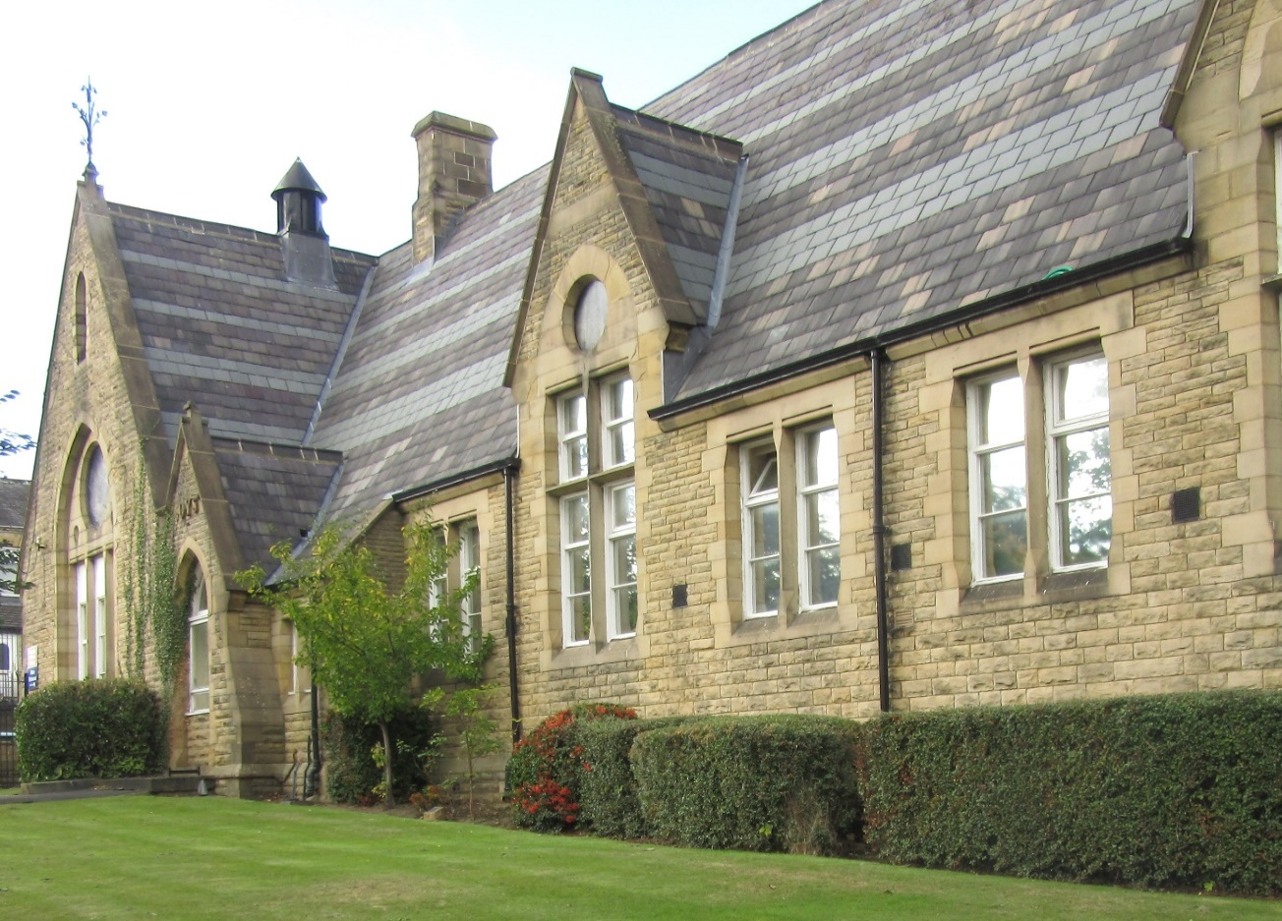

If you would like a copy of any of our school policies please ask at the office

Welcome

Dear Parents and Carers

We are proud of our school and our learners.

Our school promotes positive relationships with all stakeholders to create a happy, secure, caring, positive and fun environment where all learners have the right to learn. Every child is treated as an individual and as an important member of the school community.

By nurturing positive working relationships with parents, carers and children we believe that we provide children with the best care, support, education and opportunities.

We look forward to working with you to help your child achieve to their full potential.

Yours sincerely

Mrs S Nazam
Headteacher
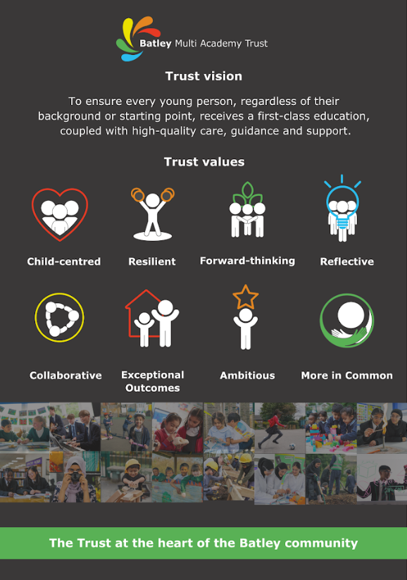

Collaborate |  | Aspire |  | Respect |  | Empathy

Learners are at the heart of every decision we make

Introduction

The aim at Purlwell Infant and Nursery School is for all learners to be educated to a high standard and to reach their full potential in all aspects of school life.

By the time they leave Purlwell, the learners are expected to be independent, self-disciplined, to have an awareness of the world they live in and to possess high self-esteem.

Our school is a Victorian building built in the 1800s and extended in 1983. There are at present nine teaching areas plus a hall, a Headteacher’s office, admin office, a staffroom, library, intervention suite, administration meeting room, resource room and School Business Managers office. There is also a large nursery and a separate pre-nursery. To the exterior there is a large tarmac playground with climbing frame and a separate Foundation Stage playground.
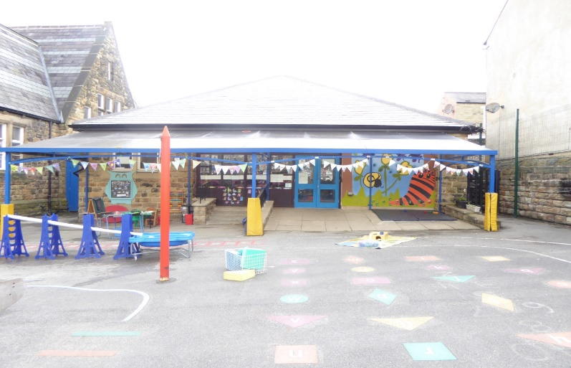

Visits to school

We encourage prospective parents to visit our school. If you would like to come and have a look at what we get up to at Purlwell Infant and Nursery School, please phone the school office to make an appointment.

Tel: 01924 326734

There is a range of information on the school website.

Ofsted report

Here are some of the quotes from our last Ofsted report in March 2022:

- This school continues to be good.
- This is a school at the heart of the community
- Positive and caring relationships between all adults and pupils are a key feature of Purlwell Infant and Nursery School.
- Pupils demonstrate excellent learning behaviours.
- Pupils feel safe and know that they can speak to any adult in school if they are worried. There have been no reported incidents of bullying.
- Parents welcome the extraordinary lengths that staff go to, to care for their children.
- Leaders have established an ambitious and well-sequenced curriculum.
- The early years curriculum is carefully designed to ensure that it introduces the core knowledge and skills that children will need to be successful in key stage 1.
- A mastery approach to mathematics is well established in all year groups.
- Teachers ensure that pupils develop a strong understanding of positive friendships and relationships
- A broad range of trips and visitors help to widen pupils’ learning experiences.
- All staff speak positively about the strong team ethos across the school.
- Governors have an informed understanding of school developments.
- Leaders ensure that staff have the training they need to keep pupils safe.

School Address: Purlwell Infant & Nursery School
Purlwell Lane
Batley
West Yorkshire
WF17 7PE

Telephone No: 01924 326734
E-Mail Address: office@purlwellschool.co.uk
Website: www.purlwell.org
Instagram: purlwell_eyfs

School office is open: 8.30am to 3.30pm (answering machine available 24 hours)

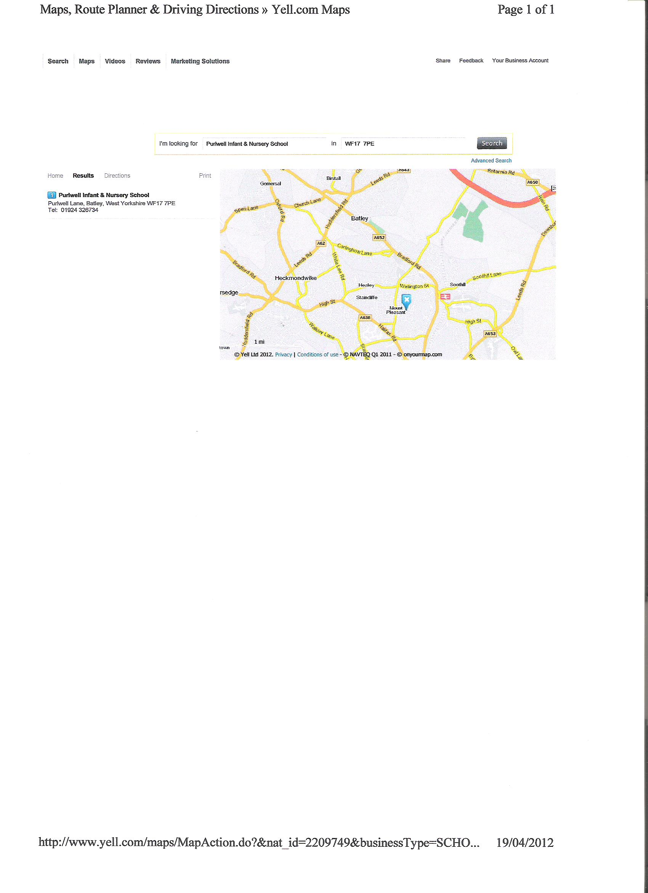

Our Aims:

- To create a caring, stimulating and organised environment where children feel safe, secure, happy and confident.

- To provide high quality enjoyable and awe-inspiring teaching and learning experiences through a broad, balanced, relevant and differentiated curriculum that meets the needs of all learners equally, including those with special educational needs.

- To provide opportunities for learners to develop their speaking and listening skills, expand their vocabulary and develop in confidence, so they are able to speak to and perform in front of different audiences.

- To actively encourage the development of skills and attitudes that will promote independence, perseverance and resilience.

- To promote good attendance of all to ensure there is no lost learning time, because every second counts to succeed.

- To build positive relationships with parents and other stakeholders to work for the benefit of all our community.

- To nurture, encourage and provide opportunities for everyone to reach their full potential.

- To establish a learning community, where through mutual care, respect and consideration everyone supports each other to continually develop and succeed.

- To enable all learners to achieve the highest possible standards in all areas of the curriculum by investing in resources and CPD opportunities for staff that will facilitate this.

- To ensure all learners are prepared for the next phase of their education through effective, relevant transition opportunities.

Our aims will be achieved through relevant targets on the School Development Plan, Action Plans and in policies and procedures that underpin good practice.

OUR CURRICULUM OFFER

By the end of their time at our school learners will have;
- Achieved to their full potential
- Achieved age expected standards or above in reading, writing and maths
- Achieved the key skills of teamwork, independence and cooperation.
Learners will have participated in;
- A broad and balanced curriculum
- Activities to develop an understanding of diversity and respect
- Charitable giving
- Participated in a live performance
- Outdoor activities
- Offsite visits to enrich core learning
- Enterprise activities
- Community activities
- An environmental project
- After school clubs
- Cooking
- A democratic process
- Representing their school
- Road safety lessons
- A mosque and church visit
- A weekly time of reflection
- Opportunities to take responsibilities
- Playing a musical instrument

Everyone will have experienced;
- A feeling of being included
- Being listened to
- Being encouraged
- Being challenged
- Being prepared for their next step in education
- Being respected
A safe environment, knowing how to ask for help.

School Organisation

Learners spend 4 years at Purlwell School from Nursery through to Year 2 and each year group is classified as follows:

- 3 – 4 years old Early Years Foundation Stage - Nursery
- 4 – 5 years old Early Years Foundation Stage - Reception
- 5 – 6 years old Key Stage 1 - Year 1
- 6 – 7 years old Key Stage 1 - Year 2

The number of learners on roll and the number in each year group govern the arrangement of the classes. This often changes from year to year. Class sizes are kept as small and balanced as possible. Within each class, learners are taught individually, in groups and as a whole class according to their learning needs and ability.

Reception and Nursery learners follow the Early Years Foundation Stage curriculum. Learners in Years 1 and 2 study the National Curriculum. This underpins all future learning by supporting, fostering and promoting learner’s development.

Communication with Families

The school uses every opportunity to communicate effectively with all community members. This is achieved by using a range of strategies including:

- Letters home (read to all learners in advance where appropriate)
- Email (we are using this mode of communication most)
- Newsletters
- Notice Boards
- School website
- Parents’ evenings
- Reports
- Text messaging
- Instagram

Parents are encouraged to communicate with school and their support and opinions are valued.

Working with Families

We encourage parents and family members to come into school and to be fully involved in their children’s education. If necessary, appointments can be made with your child’s class teacher or the Headteacher to discuss issues relating to your child. Bi-lingual support is available if required.

Parent’s evenings are held twice a year, when teachers report on learner’s progress and set targets for future progress. In addition written reports are also provided at the end of each academic year.

During the year a number of other events, workshops, parent forums and meetings are held to which we invite parents to. We hope you will try to attend these events as they are invaluable in supporting your child’s education.

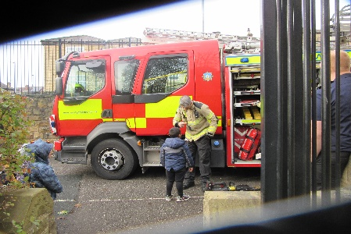
Events during the year include:

- Parents’ welcome meetings
- Curriculum meetings
- Class assemblies
- Winter and Summer fairs
- Festival day
- Open mornings
- Sports day
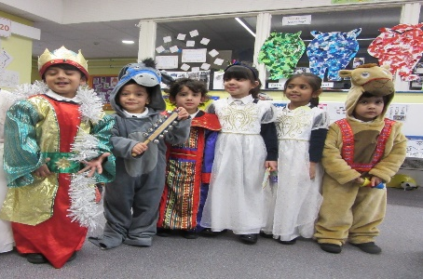
- Inter school sports events
- Parents evenings
- Nativity performance
- Ramadan performance
- Parent workshops
- Fundraising events



School council

We fully recognise the importance of pupil voice and involving the people who really count, in the development of the school. The learners in each class elect their own school council members. The elections are held every September to allow all pupils the chance to stand.

The school council meets most weeks to discuss school improvement. Leaners opinions are sought on a wide range of issues.

Admissions Procedures

The school is a community primary co-educational day school catering for children in the age range 3 to 7 years.

Prospective parents are invited to visit the school at any time with or without their child by prior arrangement with the Headteacher.

Purlwell Infant and Nursery school has a one hundred and four place Nursery offering part-time places for pupils, in the term after their third birthday. Parents are advised to put your child’s name on the waiting list at the earliest opportunity.

Kirklees Local Authority controls the admissions policy for all full time pupils which is set out below:

Priorities for school admissions of statutory school age – Year Reception to Year 2

- Children in public care (Looked After Children)
- Children who live in the school’s Priority Admission Area (PAA) who have an older brother or sister attending from the same address at the date of admission (younger sibling rule)
- Children who live in the school’s PAA
- Children who live outside the school’s PAA who have an older brother or sister attending from the same address at the time of admission (younger sibling rule)
- Children who live outside the school’s PAA

Community and voluntary controlled schools will admit children with a Statement of Special Education Needs where the school is named in the statement.

For any further information please write to:

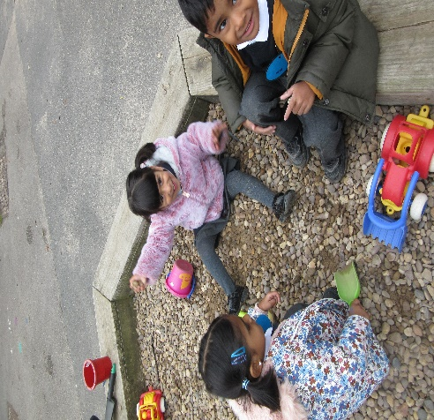
Directorate for Children & Young People
School Admissions
Kirkgate Buildings
Byram Street
Huddersfield
HD1 1BY

Tel: 01484 225007
Email: pupiladmissions@kirklees.gov.uk

Pre-School Education at Purlwell – Ready Steady Group

At Purlwell we recognise that a learners first educator is the parent, therefore it is essential that we all work together to develop a partnership between home and school at the earliest opportunity.

The term before leaners start nursery, parents and children are invited to attend Ready Steady group sessions, these help support a smooth transition. Purlwell staff run the sessions and all parents and learners are encouraged to attend. Please speak to the school office for an application form.

Nursery

Learners will start their Nursery education in the term after their third birthday, on a part time basis. We can accommodate both the universal entitlement (15 hours) and the extended entitlement (30 hours - subject to eligibility and availability).

Nursery session is:

Morning 8.30am to 11.30am

Currently we only have morning Nursery available to our learners.

We ask that learners are brought to school in the morning and collected every day by an adult. Children will not be allowed to be taken home by anyone under the age of fourteen. If a different adult than usual is collecting your child please let staff know in advance.

In the morning the Nursery doors are opened and manned by members of staff between 8:30am and 8:45 am who will welcome the learners into school.

At the end of the session please wait for your child at the bottom of the ramp near the Nursery door. It is important that you collect your child on time, as children may become distressed if you are late. Home time is 11:30

In Nursery learners will learn through a variety of experiences and planned activities following the Early Years Foundations Stage Curriculum. These educational experiences provide learners with the foundations to build on in their later education. It is therefore a vital time in your child’s school life and regular attendance in Nursery is an expectation.

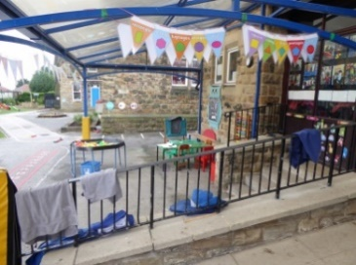
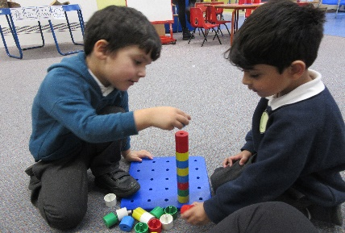
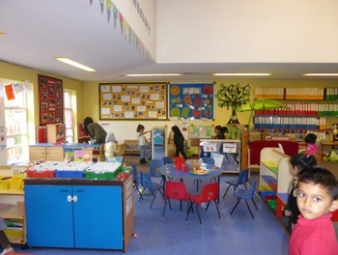

Since September 2017 our Nursery children have started wearing a uniform. Parents have welcomed this and commented that it has greatly reduced issues relating to what to wear.

Full Time education

Learners start their full time education in Reception class in the September prior to their fifth birthday. During their Reception year learners are taught according to the EYFS Curriculum.

The staffing ratio in school is good. Every class has an educational support assistant working full time alongside the class teacher. Learners will have the best opportunity to develop their skills in the English language and therefore fulfil their entitlement to be taught all areas of the EYFS.

Attendance
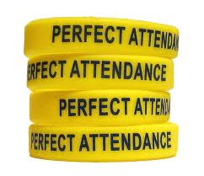
It is essential that your child comes to school every day unless they are ill.
As required by law, we keep records of all learners absence; therefore we
ask that parents inform the school as to why their child has been absent.

If your child is absent for any reason please telephone or email the school as
early as possible. If you do not inform us of why your child is absent, it is our
priority to contact you on the child’s first day of absence.

Tel: 01924 326734
Email: office@purlwellschool.co.uk

At Purlwell Infant & Nursery School the staff and Governors believe that:

Regular attendance and punctuality are essential

Early Years and Key stage one are very important stage of education where foundations are laid for the future. Time missed in school is time lost in learning.

As parents, you are aware that you have a legal duty to send your child to school regularly. The Local Authority (LA) has the power to prosecute parents under the 1996 education act, section 444.

The law states that:

‘Any person found guilty of an offence against section 444 of the 1996 education act shall be liable for a fine not exceeding £1000’

At Purlwell attendance is closely monitored by Mrs Walker our Attendance Officer and letters are sent from the Headteacher if any child’s attendance is below 90%.

Examples of Authorised Absence

- Illness
- Religious observance
- Family circumstances (ONLY after consultation with the Headteacher)

Examples of Unauthorised Absence

- Routine dental/medical appointments
- Shopping (for school or otherwise)
- Sleeping in
- Visiting relatives, or trips to the airport
- Any absence that has not been given a reason either by phone or letter by an adult
- Absence because of a parent or sibling’s illness

What parents should do

- Telephone school as early as possible on the first day of absence
- Send a note explaining the absence when the child returns to school
- Make sure your child comes to school every day
- Tell your child how important it is to come to school
- Make routine dental, doctor or optician appointments out of the school day, or return as soon as possible after an appointment

What school will do

- Reward your child for good attendance
- Refer any persistent problems to the Attendance and Pupil Support Officer
- Help in any way we can
- Refer to the school nurse

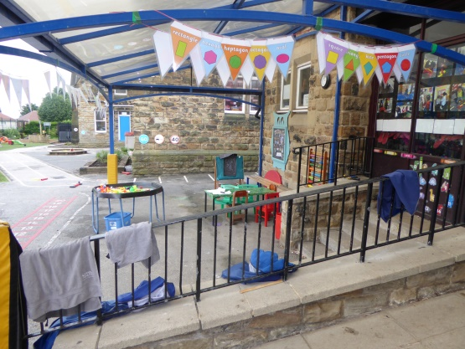
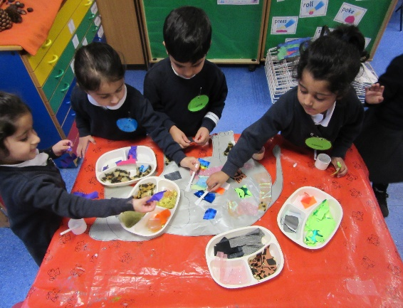

Term time holidays

Parents should avoid taking their children out of school during term time for family holidays. Such absence can be very disruptive to pupils’ learning and development. Kirklees LA and the school has a comprehensive absence policy.

You must make an appointment to see the Headteacher if you intend to take your child out of school in term time.

Trust Attendance Target: 98%

Our attendance has continued to improve and we need your support to maintain this.

Emergency School Closure

Unfortunately there are some exceptional times when the school may need to be closed for safety reasons. This would be due to weather conditions or a problem with gas, electric or water. In such cases we would try to give parents as much notice as possible prior to a closure.

- During severe weather listen to local radio stations and check the school website for updates.

- Texts will be sent to you if you have given the school an up to date mobile number.
- (please note this can only be sent to one mobile number per family).

- If there is a problem during the day we will ensure your child is safe until you are able to collect them.

- The school has procedures for dealing with evacuation and alternative provision is available if necessary.

Medicine in School


Leaners can only work well if they are fit and healthy. Please do not send
your child to school if they are unwell. However, there may be times when
your child is fit enough to be in school while finishing a course of medicine.

All medicines should be taken to the school office with clear instructions
about the administration. You will be asked to sign a form giving
permission for a member of staff to administer the necessary dose.

Only medicines prescribed by a doctor will be administered in school.

We also need to know about any underlying medical conditions so that we can make provision for your child.

School Uniform

Our school encourages the wearing of a school uniform with the school logo on, but this is not compulsory.

Sweatshirts, cardigans and waterproof coats with the school logo on are available from Smart Uniforms, 1-3 Cheapside, Bradford Road, Batley, WF17 5ND. Next to the Mill Village.

White shirt or white polo shirt |  | 
Grey trousers/ grey skirt or grey pinafore dress | 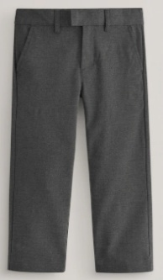 | 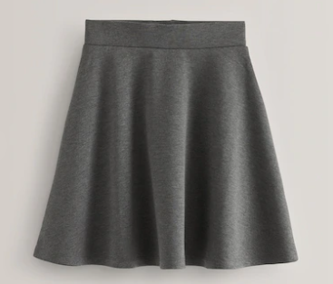 | 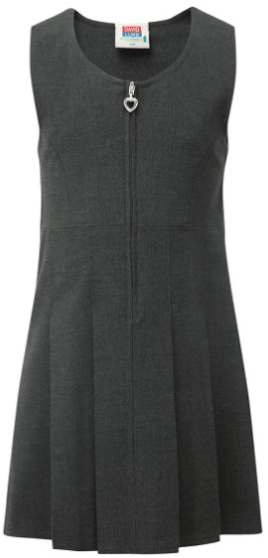
Navy blue jumper or cardigan |  | 
Summer Uniform  Blue and white checked gingham dress (can be work with white or blue leggings | 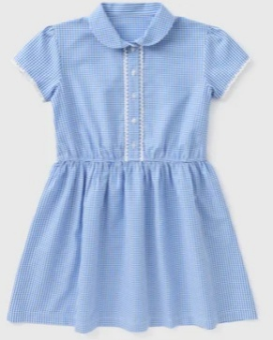 | Grey shorts  






Black shoes or completely black trainers. Sensible footwear – no open toe sandals. Hair accessories should be kept small and only blue or white


Jewellery or taweez cannot be worn during PE. Please remove these on PE days.


Snacks

Learners are offered a piece of fresh fruit or vegetable every day. Learners are

not allowed to bring sweets, crisps or chocolate at any time and chewing gum is

banned from the premises.

DO NOT BRING NUTS INTO SCHOOL

Milk

Milk in the Nursery is free for all learners. For full time pupils, from the age of 5, milk is charged termly and the local authority subsidises this. This is payable at the end of the term and orders cannot be changed once the term has begun. All learners are encouraged to drink milk unless they have an intolerance or allergy to it.

Lost Property

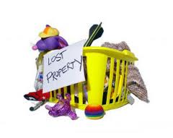
Naming all items of clothing reduces the risk of losing things. Please

name items of leaners clothing. We do keep lost property for a

reasonable period of time, but it is often difficult to identify items that

are not labelled. If your child has lost something please check in their

classroom first and then in the lost property box.

First Aid

The school ensures that we have staff that are trained in administering first aid. Simple first aid is given at school when necessary. If an accident needs further medical attention we will make every effort to contact you first.

PLEASE ENSURE YOUR CONTACT DETAILS ARE UP TO DATE!

We have approximately 16 first aiders in school.

Informal/Formal complaints

Any concerns and complaints about school matters should be first brought to the attention of the relevant staff. Every effort will be made to address and resolve any concerns as soon as possible. The schools concerns and complaints policy will be followed. The policy can be accessed on the school website.

Our School Curriculum

The school has a statutory responsibility to follow the Early Years Foundation Stage Curriculum in Nursery and Reception class and the National curriculum in Key Stage One.
In Years 1 and 2 (Key Stage One) of your child’s education, lessons are taught in accordance with the National Curriculum. Literacy and Numeracy lessons take place every day in Key Stage one and teaching is approached through cross curricular themes.

Each year group sends out a newsletter with curriculum information sheet each half term. This tells parents what their child will be working on for the coming weeks and how they can support them with language, vocabulary and homework.

Reading books

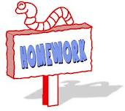
Every learner at our school is encouraged to bring home shared reader books and
read to their parents at home. Learners need to have a named book bag to keep
these books safe along with vocabulary cards which they will also be given to
practice. Book bags can be purchased from the school office for £4.

You will be invited to attend ‘morning readers’ which will take place once each week. This is time for you to come into the classroom with your child and share a book.

Parents are asked to ensure learners take care of the books at home. A charge of £5.00 is made if a book is damaged, defaced or lost.

This is a good opportunity for parents to talk to children about what they have been learning at school.



SATs results and Teacher Assessments

We are very proud of the individual achievements and progress learners at our school make. Data shows that learners make good progress from their starting points into Nursery. Learners progress and attainment are measured using the following procedures:

- Teacher assessments of learners work are made continually throughout the year by every teacher.

- Statutory Early Years assessments during the Reception Year.

- Statutory Phonics test at the end of Year 1.

- Nationally standardised tasks or tests are undertaken by all learners at the end of Key Stage one / Year 2. These are referred to as SATS or Standardised Attainment Tests.

We analyse our results and then support learners accordingly. Parents, the local authority and your child’s next school are informed of your child’s SAT results.

Special Educational Needs

At Purlwell we will admit all eligible leaners, regardless of their needs, provided we feel we can support their needs. We work closely with parents to ensure any transition runs as smoothly as possible.

Most learners require extra support from time to time. If we think this is the case for your child we will discuss our concerns with you and recommend some form of support. Likewise if you have any concerns about your child, please do not hesitate to contact us.

Sometimes after working with you to support your child, we may decide to seek advice from an agency outside of school. With your permission, this advice may lead to your child receiving extra support from a specialist coming into school to work with your child for a short period of time. It is possible that after seeking advice from specialists a formal Statement of Special Educational Needs may be sought to enable your child to receive more long term support. Some examples of short and long term support available include:

- Support with learning difficulties
- Speech and Language therapy
- Support for visual difficulties
- Support for hearing difficulties
- Support for emotional or behavioural difficulties
- Physiotherapy.

A copy of the schools’ Special Educational Needs Policy is available on request and on the school website.

Accessibility

The arrangements for the admission of learners with disabilities are in line with the LA’s policy and seek to ensure that the needs of all learners are recognised and the placement is appropriate to their needs. The school’s Inclusion Policy ensures that there is no discrimination either direct or indirect against disabled pupils.

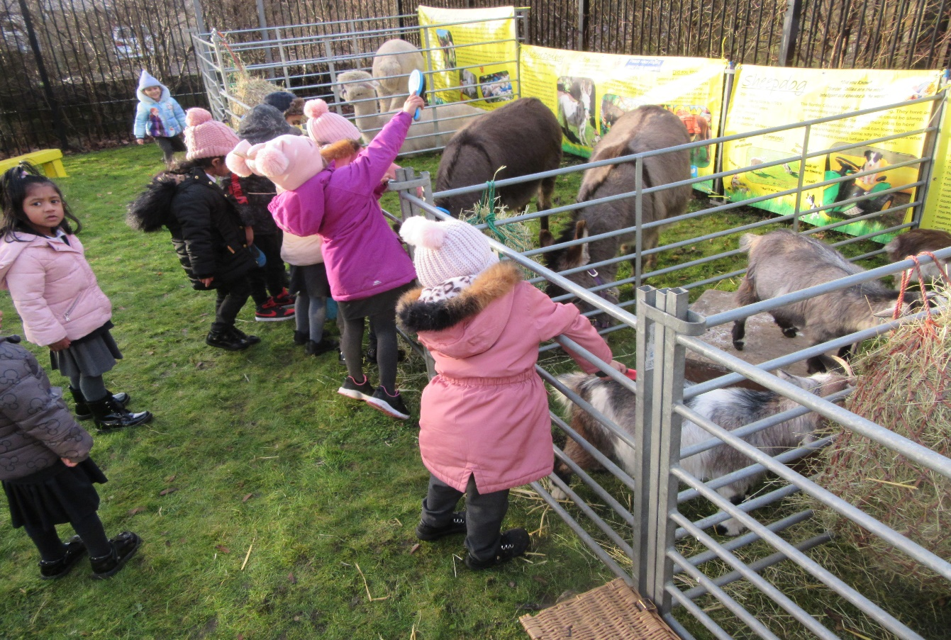

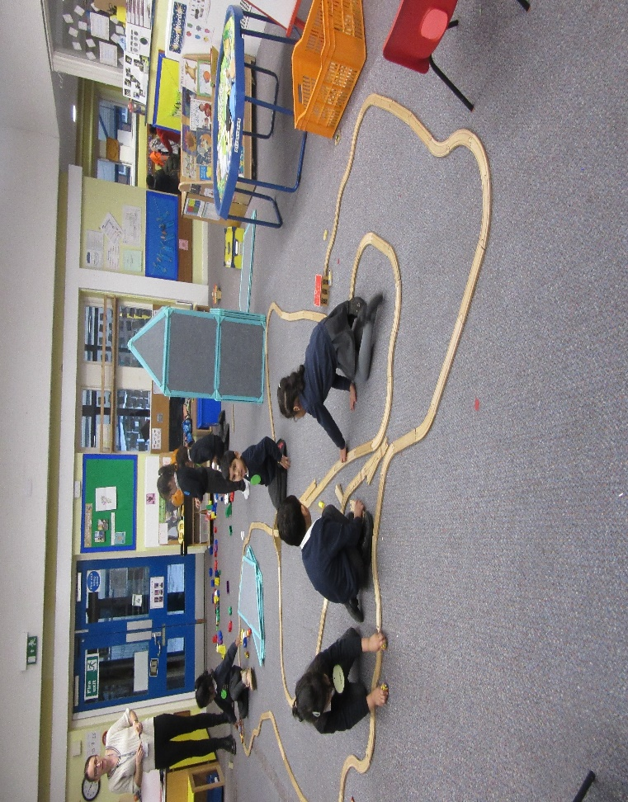
Safeguarding

“Safeguarding is everyone’s business – so never ever do nothing”

(A combination of two quotes by Lord Laming following the death of Victoria Climbie)

Designated Safeguarding Lead (DSL): Mrs S Nazam – Headteacher
Mrs S Gallivan – Deputy Head

Deputy DSL: Mrs J Shires
Mrs J Hamilton

Link Governors: Mrs S Palmer Mr A Patel

Purlwell Infant and Nursery School is committed to ensuring the welfare and safety of all leaners in school. All Kirklees schools, including ours, follow the Kirklees Safeguarding Children Board Procedures. The school will, in most cases, endeavour to discuss all concerns about learners with their parents. However, there may be exceptional circumstances when the school will discuss concerns with the Duty and Assessment Social Care team and / or the police without parental knowledge (in accordance with Kirklees Safeguarding Children Procedures). The school will of course, always aim to maintain a positive relationship with parents. The school’s Safeguarding policy is available on the school website.

Safer recruitment – All staff appointed to Purlwell Infant and Nursery school are subject to an enhanced Criminal Records Bureau (CRB) check or Disclosure Barring Service check.

Safeguarding – All staff are trained in Safeguarding procedures: The training includes understanding what is meant by physical, emotional, sexual abuse and neglect and how to recognise signs of these. Staff have also been trained in what to do if they suspect abuse, or if the abuse is disclosed to them. All disclosures or suspicions of abuse may be reported to the Designated Safeguarding Lead or directly to Kirklees Safeguarding and Assessment Service. In the absence of the Designated Safeguarding Lead reports are made to the Deputy Designated Safeguarding Lead. All referrals are dealt with following the Kirklees Safeguarding Children Board procedures. The Designated Lead Teachers for Safeguarding are Mrs Gallivan and Mrs Nazam.

Online Safety

Every school has the responsibility of teaching learners on how to keep safe when using the Internet. The Internet is such a valuable resource but poses so many threats to the safety and wellbeing of the person using it. Learners are taught in school how to stay safe on the Internet and leaflets giving advice to parents are available.

If you have any concerns regarding Safeguarding issues please contact the Headteacher.

A copy of the schools safeguarding policy is available on request and on the school website.

School Governors

The school’s Governing Body is involved in all aspects of school life. They act as a corporate body and support the school’s ethos. They are responsible for the strategic overview of the school through staff recruitment, agreeing policies and priorities and monitoring and reviewing whole school targets.

When a vacancy for a Parent Governor arises, all parents with a child in the school are notified.

Governing Body

Mrs S Palmer – Chair of Governors

Mrs Gallivan
Mrs Z Badat
Mrs S Nazam
Mrs T Rafique
Mrs H Cassamoali
Dr F McGregor
Mr A Patel
Mrs A Khan

School organisation 2026-2027

Teaching Staff

Mrs S Gallivan Head of School/SENCO/DSL
Mrs A Boynton Assistant Head/DSL (support SENDCO)

Ms N Afsha
Mrs A Hadaway
Mrs A Boynton
Miss L Hinchliffe
Mrs J Dransfield
Mrs P Taylor
Mr J Field
Mrs K Patel

Teaching Assistants
Mrs C McGowan ( Nursery Nurse)
Miss Z Ali (Nursery Nurse) Mrs S Bhula
Mrs N Daji Mrs J Shires (HLTA) – Deputy DSL
Mr N Siddique Mrs F Daji
Mrs C Rutledge Mrs A Mamaniat
Mrs J Hamilton - Deputy DSL Mrs S Seedat
Mrs A Chopdat Mrs M Yasir

Office Staff

Mrs L Walker – Senior Business Support Officer
Mrs S Munir – Business Support Officer

Premises

Mr H Bham – Caretaker

Code of conduct for Adults on the grounds of Purlwell I & Nursery School

To ensure a safe, warm and welcoming environment for our learners, we understand that we all need to work together. We expect adults to:

- Demonstrate that all members of the school community should be treated with respect and therefore set a good example in their own speech and behaviour.

- Seek to clarify a child’s version of events with the school’s view in order to bring about a peaceful solution to any issue.

- Correct own child’s behaviour.

- Approach the class teacher to help resolve any issues of concern

- Approach the Headteacher if the concern remains unresolved

Adults please refrain from the following:

- Disruptive behaviour which interferes or threatens to interfere with the operation of a classroom, office area or any other area of the school ground.

- Using loud/or offensive language, swearing, cursing, using profane language or displaying temper.

- Threatening to do actual bodily harm to a member of school staff, visitor, fellow parent/carer or child regardless of whether or not the behaviour constitutes a criminal offence.

  - Damaging or destroying school property.

  - Abusive or threatening e-mails or text/voicemail/phone messages or other written communication.

  - Defamation of the school’s or staff character on social sites.

  - Approaching another learner or their parent in order to discuss or chastise them because of their actions towards your own child. (Such an approach to a child may be seen to be an assault on that child and may have legal consequences).

  - Smoking and consumption of alcohol or other drugs.

  - Wearing inappropriate clothing. For example those that are too revealing.

Should any of the above behaviour occur on school premises the school may feel it is necessary to contact the appropriate authorities and, if necessary, even ban the offending adult from entering the school grounds.

We trust that parents and carers will assist our school with the implementation of this policy and we thank you for your continuing support of the school.

Holidays 2026/2027

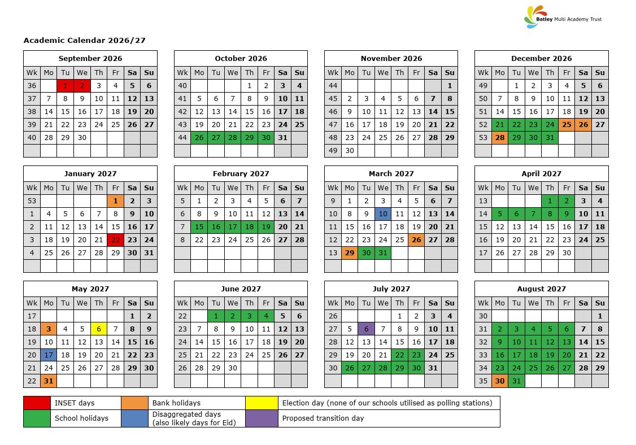
Please ensure that all trips are taken during the school holidays. Poor attendance can result in a penalty notice or in extreme cases prosecution, however the impact on your child/children’s education and future can be far greater. Good attendance is a skill for life and attendance has an impact on a child’s whole school experience. As well as affecting your child’s academic potential, poor or irregular attendance can have an impact on your child’s friendships, self-esteem and confidence.

Any pupil who takes a term time holiday for 10 days in a single academic year can only achieve a maximum of 94.7% attendance, assuming there is no additional absence. This is below average attendance and will impact on pupil progress.

Thank you in advance to all the families who are supporting the school by ensuring their children attend school every day.



